Ashley Krause
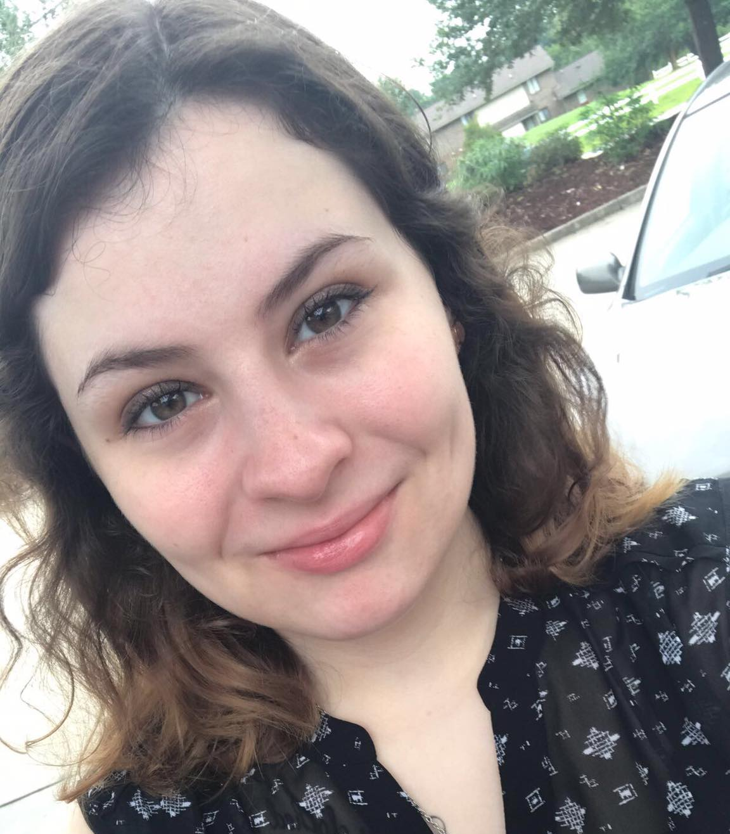
About Me:
My name is Ashley. I am a sophomore Psychology major at Francis Marion University. I’ve been participating in a class focused on racial awareness this semester. I’ve learned a lot about myself and my opinions. I want to tell you more about the importance of speaking up and how it has changed who I am and how I look at the world around me.

Feelings of extreme dread and apprehension were at the forefront of my mind when I walked through the classroom doors to our first small group meeting. I sat down at the empty table with my walls completely up. Taking off the mask I have worn for so many years and finally bearing how I really felt was something I didn’t want to do. It’s terrifying to be honest with someone about how you feel. For the longest time, I sat quietly in our group fighting my thoughts and asking myself many questions: why am I here, do these people understand me, and why did I sign up? The questions I asked myself led me to periods of serious introspection. I wanted to know the truth about my opinions.
It took months for my peers to get me to open up about how I was feeling, even if it was just a slight change from our previous meetings. I had so many fears about how they would view me after I told them what had been bothering me.
One day, I found a spark inside of me that gave me the courage to speak up. I was able to voice the main reason why I was keeping quiet during our group meetings. In almost every meeting we had, we found ourselves approaching the subject of how politics and racial issues relate. It is almost impossible to ignore a perpetrator of this issue, our new president, when talking about this subject. One question that we found ourselves asking constantly was: are all Trump supporters racist?
The first time this topic was brought up, I felt the already enormous pit in my stomach grow twice in size. I kept my mouth shut when this topic was brought up mostly because I felt like I was keeping a huge secret from everyone. That secret was: I voted for Trump. I didn’t want the friendships I had formed in this group to be ruined by something I had done in my past. I had regretted the decision I made to vote for Trump ever since election day.
I felt completely different after I spoke up about how I was feeling. I was finally able to be the true me after I let out the emotions that had been bothering me for weeks. My group members didn’t even care that I voted for Trump. They cared that I was honest with them about why I was uncomfortable in the group setting.
I spoke up. I still have a lot of work to do when it comes to forming my own opinions on the controversial issues in our world, and that’s okay. We are humans and that means we are in a state of constant evolution.
It’s so important to be honest about how you are feeling because other people might be feeling that way. Even though you aren’t sure how someone is going to feel after you speak up, you should speak up anyways.
I no longer sit down at that scary table. At the end of the class we sat in a circle as friends with walls no longer up. That table that sat in the corner of the room reminded me of the progress I made and the walls I let down.

