Measures for an intervention to reduce implicit racial bias in college students.
William P. Wattles, Ph.D. & Chaniqua Mazyck, B.S.,
Francis Marion University
39th Annual NITOP January 3–6, 2017, St. Pete Beach, Florida
Fifty-two years after the Civil Rights act and sixty-two years after Brown vs. The Board of Education great racial disparities still exist in America. The Pew Charitable trust reported that median wealth of college-educated white households ($301,300) is more than 11 times that of black households ($26,300) with similar education levels. While 81% of African-Americans with at least some college say they have been discriminated against due to race, sixty-two percent of whites report that race has little to do with their level of success. (Pew, 2016)
Seventy-eight percent of whites hold the optimistic view that the U.S. either has (38%) or will (40%) make the changes necessary to give blacks equality with whites. Of blacks few believe equality has been reached (8%) while 42% believe it will be eventually (Pew, 2016.) Suggestions that the election of Barack Obama has shown America to be post-racial have led to the supreme court eliminating key aspects of the Voting Rights act of 1965 (Liptak, A, 2016.) Recently we used data about South Carolina voter registration (South Carolina Voter Registration Demographics,December 19, 2016) and results of the recent election (South Carolina Results, December 19, 2016) to look at the relationship between racial make-up and voting results in the counties of South Carolina. As shown in figure 1, the percent of white voters correlated .92 with percent voting for Trump. Thus, 85% of the variance in voting can be explained merely by knowing the racial make-up of the electorate.
Racial microaggressions (Sue, et al, 2007) are insults, indignities, and marginalizing messages sent by well-meaning people unaware of the hidden messages. Psychology now knows that a great deal of our behavior and attitudes are based on automatic associations made outside of awareness (Khaneman, 2011). Thus, many people insist that they have no racial bias and are unaware of their biases. Dovidio (Mitchel, 2015) stated that while whites often believe they are color blind and don’t see race, their biases are pervasive and have a huge pernicious effect on blacks. The Implicit Association Test (Banaji & Greenwald, 2013) demonstrated that when measured in such a way that they could not choose a conscious answer, the majority (about 75%) of Americans showed a preference for whites over blacks. Thus, while “Explicit bias is infrequent; implicit bias is pervasive.” (Banaji & Greenwald, 2013, p. 208.)
Our goal is to attempt to replicate efforts to change biases using in-person groups and e-mail assignments using methods identified by Devine, Forscher, Austin and Cox ( 2012). A first step is to verify measures we plan to use to demonstrate a reduced bias.
Method
The Implicit Association Test (Banaji & Greenwald, 2013) provides an important tool in understanding prejudice as it goes underground. With people less inclined to admit to or even be aware of racial bias research questionnaires with high face validity can give a distorted message. The IAT is available on the web but reports results only categorically. However, a Free IAT which can be downloaded allows researchers to collect quantitative data on implicit bias. We used the on-line version of the IAT to validate the results we got from the in-house version created from the Free IAT.
In addition we used the Symbolic Racism 2000 Scale (Henry & Sears, 2002) as an explicit measure of racial bias.
Forty-five students in an introductory psychology lab took the on-line version of the IAT. They then completed the Symbolic Racism Scale and then retook the IAT in-house version.
Results
For the African-America students the results were very similar for the IAT on-line and the IAT in-house. (see Table 1) However, nearly one third of the European-American students showed a major shift upon taking the in-house version.
As expected black students scored lower on the Symbolic Racism Scale M=.29, SD=.12 than white students, M=.39, SD=.16, t (42) =-2.28, p< .05. d=.80.
They also had higher average scores on the In-house IAT ,M=.30, SD=.47 than white students M=-.15, SD=.49, t (41)=3.10, p <.01, d=.96. A positive number here indicates a preference for blacks over whites and a negative number indicates an implicit preference for whites over blacks.
Discussion
An in-house version of the IAT offers notable advantages. Researchers are able to obtain quantitative measures which improve statistical power. Scores can be obtained more anonymously via ID numbers without intervention. Recording of scores is done automatically.
The change in white student scores on the IAT from one version to the other is troubling and puzzling. Because we did not control for order effect, interpreting the change is difficult. Each student completed the on-line IAT with the expected distribution with most indicating a preference for whites over blacks. They then received their results indicating that preference and were asked to complete a very obvious racial bias scale. Six of the twenty subjects then showed a significant shift to the side indicating a preference for blacks over whites.
This shift could reflect boredom with the task, frustration with being labeled biased or a practice effect. The IAT is not thought to be susceptible to deliberate faking so it seems unlikely that the students have changed their answers to appear less biased. Perhaps the priming associated with the results and the obvious measure led to an increased sensitivity to issues of race. Thus, the white students may have had a temporary reduction in bias. Receiving a result indicating that one has a bias for white over black, followed by the Symbolic Racism Scale which forces the individual to confront the ugly reality of prejudice may have an emotional impact. We plan to test this hypothesis by redoing the assessments and counterbalancing for order effects.
Clearly the results could be an artifact of a small sample size as well.
References
Banaji, M. R. & Greenwald, A. G. (2013). Blind Spot: Hidden Biases of Good People. New York: Delacorte Press.
Devine, P. G., Forscher, P. S., Austin, A. J. and Cox, W. T. (2012). Long-term reduction in implicit race bias: A prejudice habit-breaking intervention. Journal of Experimental Social Psychology, 48, 1267-1278
Henry, P. J. & Sears, D. O. (2002). The Symbolic Racism 2000 Scale. Political Psychology, 23-2, 253-283
Kahneman, D. (2011). Thinking Fast and Slow. New York: Farrar, Straus & Giroux.
Liptak, A (June 25, 2013). Supreme Court Invalidates Key Part of Voting Rights Act, New York Times, Retrieved from: http://www.nytimes.com/2013/06/26/us/supreme-court-ruling.html
Mitchel, R. (December 7, 2015). Yale professor examines unconscious biases by whites. Harvard Gazette, Retrieved from: http://news.harvard.edu/gazette/story/2015/12/yale-professor-examines-unconscious-biases-by-whites/
Pew (2016) On Views of Race and Inequality, Blacks and Whites Are Worlds Apart, Pew Research Center Social & Demographic Trends. Retrieved from http://www.pewsocialtrends.org/2016/06/27/on-views-of-race-and-inequality-blacks-and-whites-are-worlds-apart/
South Carolina Results (December 19, 2016). Retrieved from: http://www.nytimes.com/elections/results/south-carolina
South Carolina Voter Registration Demographics (December 19, 2016). Retrieved from: https://www.scvotes.org/cgi-bin/scsec/96vr?countykey=ALL&D1=RACE
Sue, D. W., Capodilupo, C. M., Torino, G. C., Bucceri, J. M., Holder, A. M. B., Nadal, K. L., & Esquilin, M. ( 2007). Racial microaggressions in everyday life: Implications for clinical practice. American Psychologist, 62, 271– 286
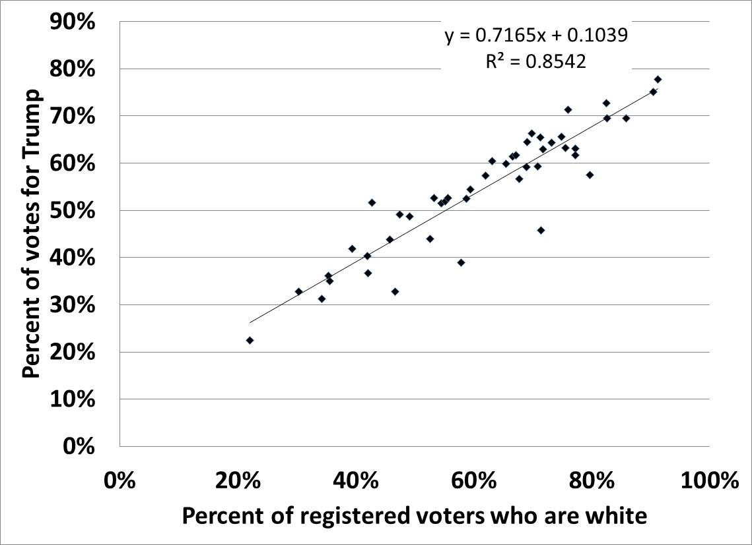

Figure 1. Percent white voters by percent of votes for Trump by county South Carolina 2016
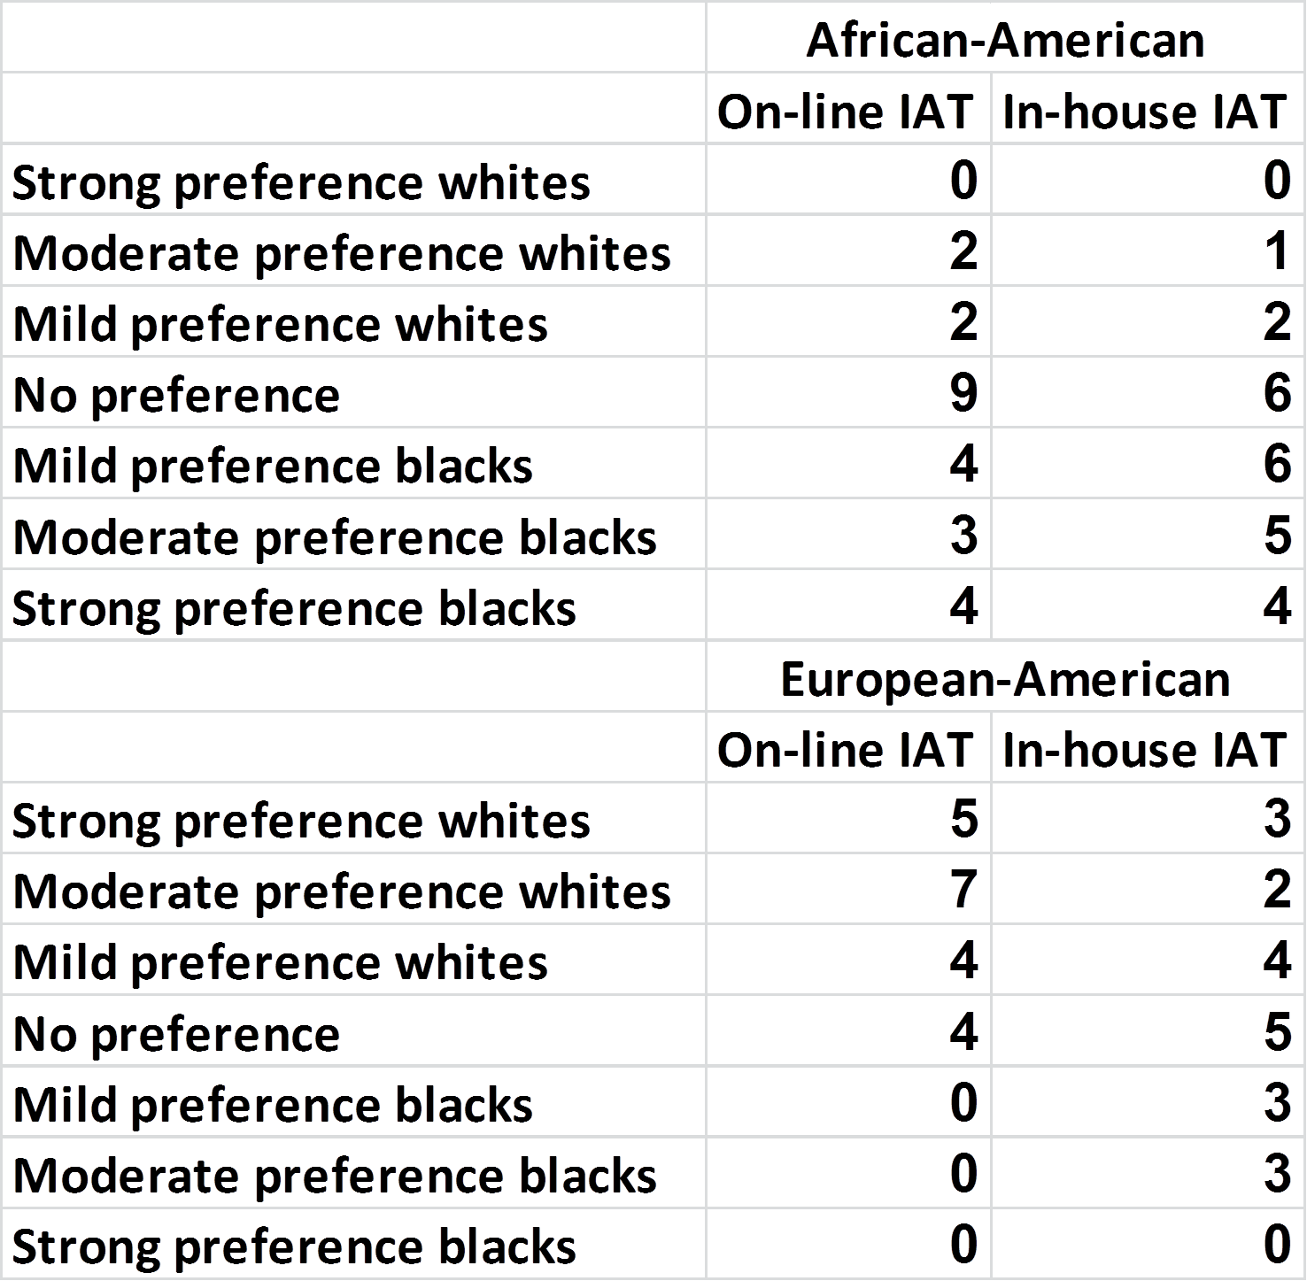

Table 1. Categorical responses to the on-line and in-house versions of the IAT.

