Student knowledge of general versus music trivia.

William P. Wattles

Francis Marion University

### Abstract

Because students often show a great deal of interest in popular music, this study tested the hypothesis that students would have more knowledge of popular music than general knowledge. Students from two sections of an introductory statistics class took two on-line quizzes designed to measure their knowledge of general trivia and music trivia. The data failed to support the hypothesis as students’ scores were not statistically different and trended in the opposite direction with the average general trivia score higher than the music trivia score.

Student knowledge of general versus music trivia

Students at many universities have been required to take statistics and they often have not wanted to do so. Whether they learn the material in a statistics class has been dependent on their motivation. Pintrich (2003) has stated that different theories of motivation can be used to explain the energizing of students and the direction of their behavior. Motivational material frequently can be idiosyncratic to the individual which makes it difficult for professors to develop themes that would interest all students. However, some generalities may have existed for groups of students. In one class, I noticed that students who seemed to have a difficult time being interested in group processes became energized to the point of yelling and interrupting one another when the subject became rap music artists. They appeared to be speaking in English but I could not really follow the conversation which was about music but kept digressing to candy (M&M) and pets (dogs). The current study examines the idea that students will be more interested in music than other material.

### **Method**

## **Participants**

Twenty-eight undergraduate students from two sections of Psychology 302, Quantitative Methods, participated as part of a class experience designed to demonstrate the origin of data. As this exercise was a class exercise with meaningless trivia questions, they were not given an informed consent, but they were informed of that right not to participate. They were told that their results would be shown to the rest of the class but would not in any way affect their grades in the course.

## **Procedure**

During the first meeting of the class students completed two on-line, ten-item quizzes. The first (Queendom.com, 1996a) purported to measure knowledge of general trivia and the second (Queendom.com, 1996b) a measure of knowledge of pop music trivia. To control for order effects, students in the first section took the general trivia quiz first while the second class began with the music trivia quiz. Results were graded by the web site and students verbally reported their grade to me for recording.

## **Results**

In contrast to my prediction, the students did not score significantly higher on the music trivia quiz (*M* = 3.57, 95% CI [4.89, 3.64], *SD* = 1.933) than on the general trivia quiz (*M* = 4.25, 95% CI [4.32, 2.82], *SD* = 1.578); the difference was not significant at an alpha level of .05, *t*(27) = 1.762, *p* = .089. *d*=.45 (see Figure 1). SPSS output for this analysis is included in Appendix A and Excel output in Appendix B. Figure 1 provides a graphical representation of this finding.

### **Discussion**

The data do not support the hypothesis that students have more knowledge of music than general information. The two highest scores were both on the music quiz so it may be true that a subset of the students have more music knowledge. Because peoples’ taste in music varies, it is also possible that the questions did not all relate to music relevant to the particular group of students. In the future it might be useful to ensure that the questions related to music popular with college students. Also I would like to measure the age of students to see if it affects their results. This would require a larger sample.

### **References**

Pintrich, P. R. (2003). A Motivational Science Perspective on the Role of Student Motivation in Learning and Teaching Contexts. *Journal of Educational Psychology, 95*. 667-686.

Queendom.com (1996a). In Common Trivia II. Retrieved January 9, 2004 from http://www.queendom.com/mindgames/quizdom/quiz178.html.

Queendom.com (1996b). In Common Trivia II. Retrieved January 9, 2004 from http://www.queendom.com/mindgames/quizdom/quiz176.html

Appendix A

*SPSS output*





Appendix B

|  |  |  |  |  |  |  |  |  |  |  |  |  |  |  |  |  |  |  |  |  |  |  |  |  |  |  |  |  |  |  |  |  |  |  |  |  |  |  |  |  |  |  |  |  |  |  |  |  |  |  |  |  |  |  |  |  |  |  |  |
| --- | --- | --- | --- | --- | --- | --- | --- | --- | --- | --- | --- | --- | --- | --- | --- | --- | --- | --- | --- | --- | --- | --- | --- | --- | --- | --- | --- | --- | --- | --- | --- | --- | --- | --- | --- | --- | --- | --- | --- | --- | --- | --- | --- | --- | --- | --- | --- | --- | --- | --- | --- | --- | --- | --- | --- | --- | --- | --- | --- |
| *Excel Output*   |  |  |  | | --- | --- | --- | | t-Test: Paired Two Sample for Means | |  | |  |  |  | |  | *general* | *music* | | Mean | 4.25 | 3.571429 | | Variance | 2.490741 | 3.73545 | | Observations | 28 | 28 | | Pearson Correlation | 0.339984 |  | | Hypothesized Mean Difference | 0 |  | | df | 27 |  | | t Stat | 1.762138 |  | | P(T<=t) one-tail | 0.044683 |  | | t Critical one-tail | 1.703288 |  | | P(T<=t) two-tail | 0.089366 |  | | t Critical two-tail | 2.05183 |  | | | | | | | | | |  | | | |  |  |  |  |  |
|  | | | | | | | | |  |  |  |  |  |  |  |  |  |
|  | | | | | | | | |  |  |  |  |  |  |  |  |  |
|  | | | | | | | | |  |  |  |  |  |  |  |  |  |
|  |  |  |  |  |  |  |  |  |  | | | | | | | | |
|  |  | | | | | | | | | | | | | | | | |
|  |  |  |  |  |  |  |  |  |  | | | | | | | | |
|  |  |  |  |  |  |  |  |  |  | | | | | | | | |

## 

Figure 1 Mean values represent number of correct responses on each type of quiz. Error bars represent 95% confidence intervals.

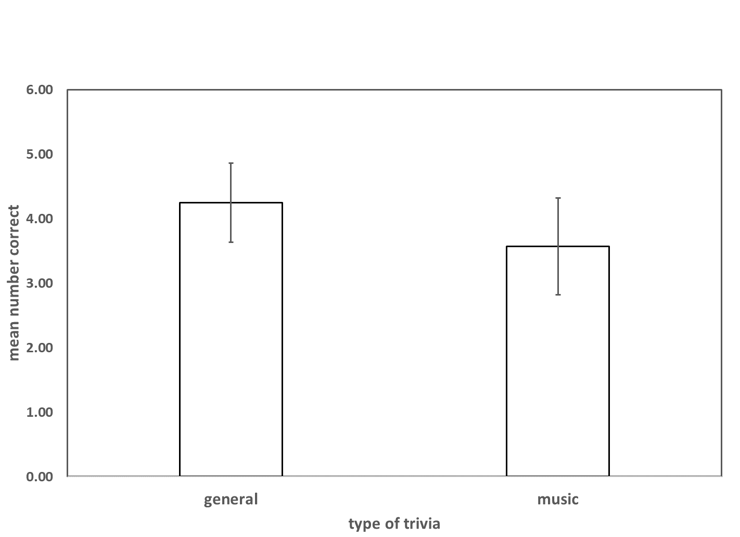

Appendix C Data

